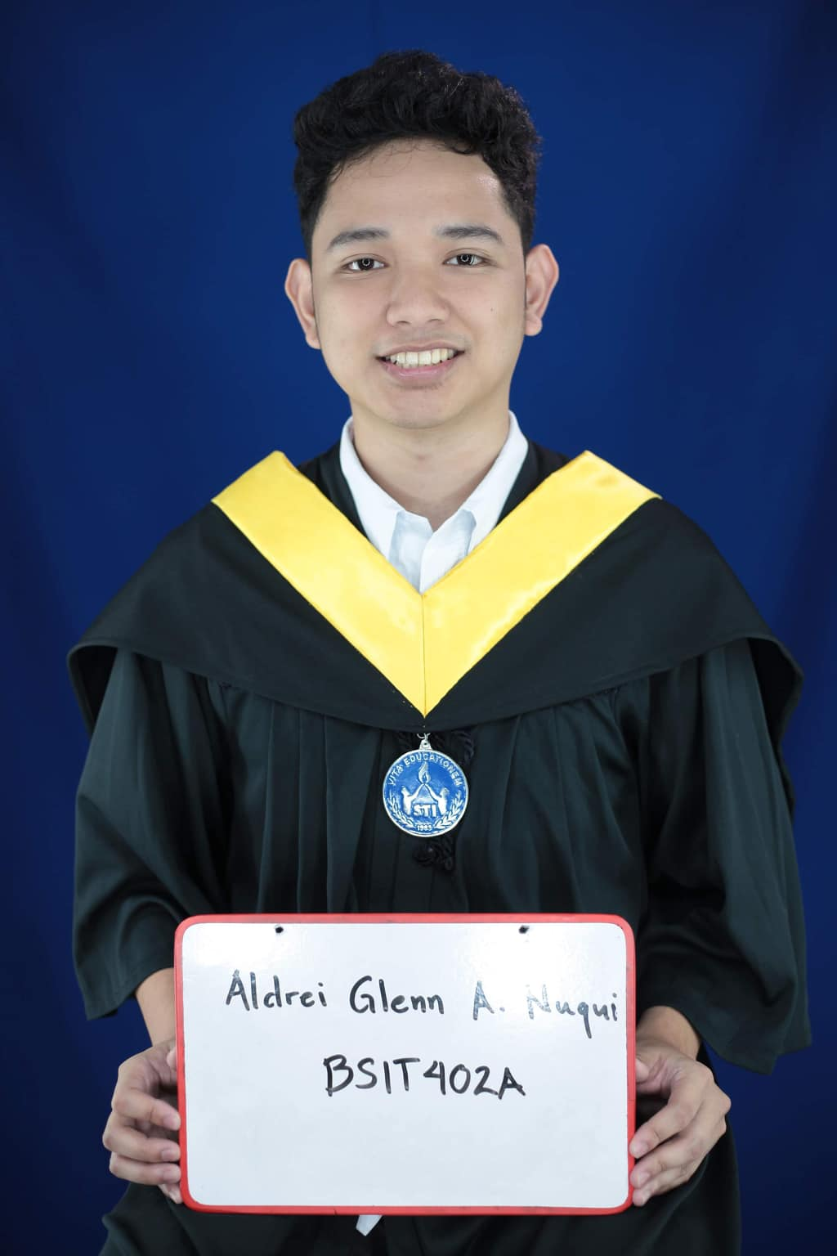

**ALDREI GLENN A. NUQUI**

**OBJECTIVE**  
To be able to practice, enhance as well as allocate my skills as an I.T. in a corporate career that inspires personal growth in a challenging way.

**EDUCATION**

**Tertiary STI College of Legazpi**

2015 -2019 692 Rizal St, Old Albay, Legazpi City

Bachelor of Science and Information Technology

2014-2015 **Informatics Computer Institute** National Highway, Tabaco City, Albay

Bachelor of Science in Information Technology

**Secondary Tabaco National High School**

2010-2014 Panal, Tabaco City, Albay

**Elementary Tabaco South Central Elementary School**

2004-2010 Divino Rostro, Tabaco City, Albay

**PROFILE**

**Age:** 23

**Date of Birth:** July 11, 1997

**Gender:** Male

**Height:** 5’6

**Weight:** 57

**Nationality:** Filipino

**Civil Status:** Single

**Religion:** Evangelical Methodist

**Address:** Cobo, Tabaco City, Albay

**CONTACT**

**WORK EXPERIENCE**

**Contact No:** 09950295014

**Email:** nuquialdrei@gmail.com

November 2019 – May 2020

**I.T. ASSOCIATE / POS Field Support**

**LCC – Mall Naga | Lion Tech Shared Services Inc.**

* Troubleshoot computer hardware, software and network.
* Complete the task in the ticket system assigned by the Helpdesk Team.
* Maintain Server and Gateway.
* Maintain POS machine and POS System.

December 2018 – March 2019

**I.T SUPPORT**

**Ninong’s Hotel | Washington, Ma. Legazpi**

* Troubleshoot computer hardware, software and network.
* Maintain CCTV Equipment
* Updated office files daily and kept records.

**SKILLS**

**Computer Hardware Servicing NCII**Date: March 2014

COMPUTER TROUBLESHOOTING

ADOBE AFTER EFFECT

MYSQL

MS WORD, MS EXCELL, POWERPOINT

JAVASCRIPT

NODEJS

REACTJS

BOOTSTRAP

CSS

HTML

MS. Maria Diejhey Martinez STI College of Legazpi

0917-108-3752 I.T. Coordinator

Mr. Joshua Imperial LCC Naga

0977-382-2165 I.T. Staff

Mr. Abril Balmaceda Ninong’s Hotel

0927-594-3391 I.T. Department Head

I hereby prove that the information in this resume is true to the best of my knowledge and belief.

ALDREI GLENN A. NUQUI

Applicant

**REFERENCES**

**EXTRA-CURRICULAR ACTIVITIES**

**Responsive Web Design**Date: February 15, 2020

https://freecodecamp.org/certification/aldreiglennnuqui/responsive-web-design

**CERTIFICATIONS**